Task-4 Penetration Testing Report
Name: Hardik Prakash Kotawdekar
ID: APSPL2635998

1. Introduction
Performed penetration testing on Metasploitable2 using Metasploit.
2. Exploitation
- Exploit: vsftpd 2.3.4 backdoor
- Got Meterpreter session
- Commands: sysinfo, getuid, shell
3. Password Attack
- Used Hydra for SSH brute force

4. Screenshots
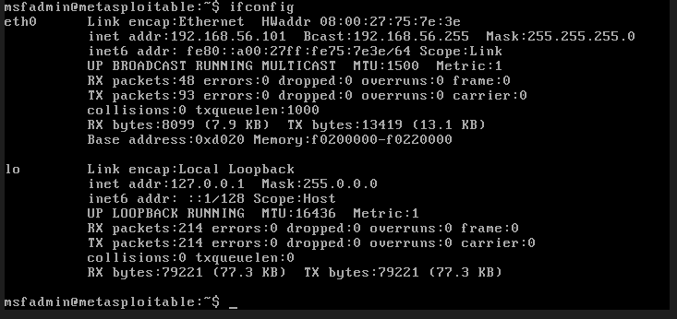

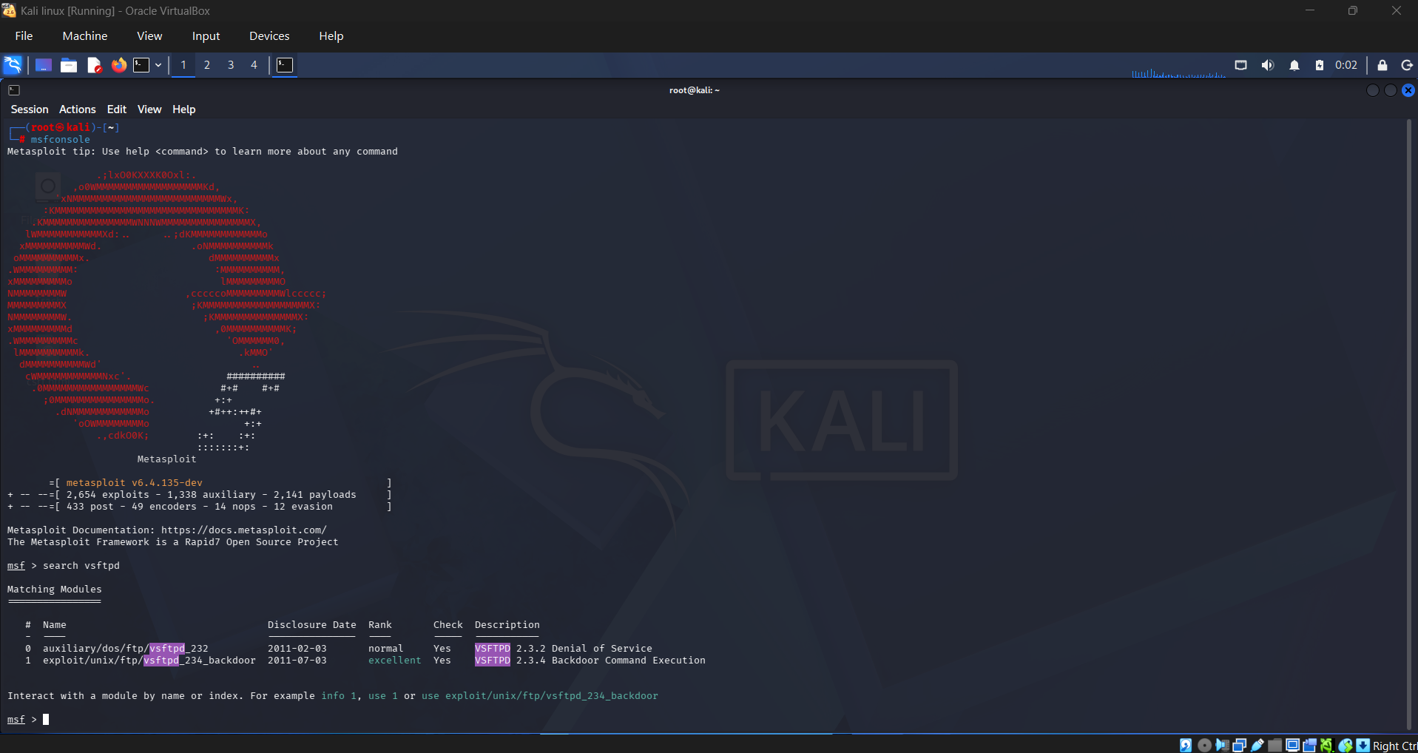
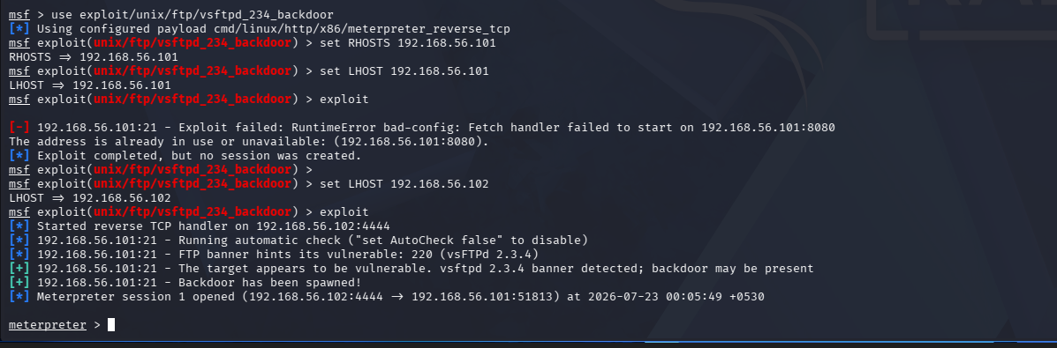
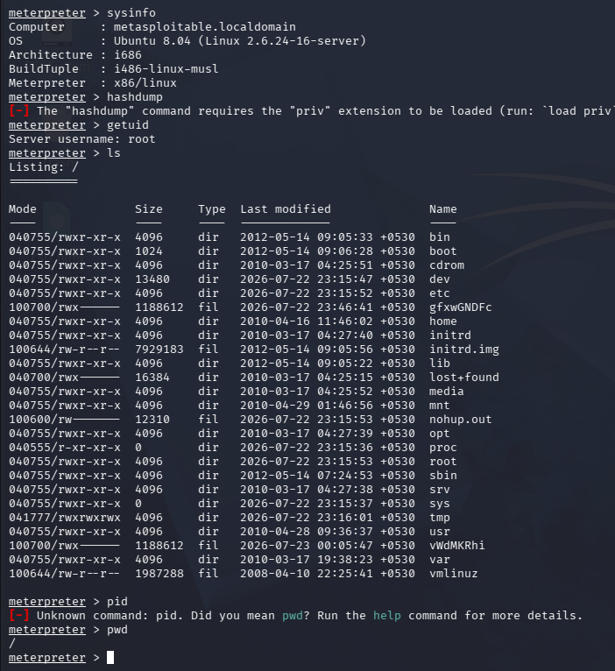
5. Conclusion
Successfully exploited system and gained access. Learned responsible exploitation.

